

WEB DEVELOPMENT

QAC020C153S



|  |  |  |  |  |  |  |  |
| --- | --- | --- | --- | --- | --- | --- | --- |
| Submission Coversheet | | | |  |  |  |  |
|  |  |  |  |  |  |  |  |
| **Student ID Number**  *(Do not include student name as anonymous marking is implemented)* | Mateusz Utracki-Janeta | | | | | | |
| **Programme Title** | Bsc Computing Technologies | | | | | | |
| **Module Title** | Website Development | | | | | | |
| **Module Code** *(listed on Moodle and in LTAFP)* |  | | | | | | |
| **Module Convenor** |  | | | | | | |
| **Coursework Title** | Unque Wears Critical Comment | | | | | | |
| **Academic Declaration:**  *Students are reminded that the electronic copy of their essay may be checked, at any point during their degree, with Turnitin or other plagiarism detection software for plagiarised material.* | | | | | | | |
| **Word Count** | 1099 | | | **Date Submitted** | | **08/04/2019** | |
|  |  | | |  | |  | |

Table of Contents

1 Research 4

1.1 HTML 4

1.2 CSS 4

1.3 Java Script 5

1.4 Responsive Web Design 5

1.5 Reflection 6

2 Usability and Accessibility 6

2.1 Perceivable 6

2.1.1 Operable 6

2.1.2 Understandable 6

2.2 Robust 6

2.3 Would you change anything and if so why? 7

3 Further Enhancements 7

3.1 Create a user login page 7

3.2 Use more java script for functionalities 7

4 References 7

# Research

## HTML

**HTML** stands for **Hyper-Text Markup Language** it is a set of markup symbols called tags that give browser directions on how to display elements on the page. Different tags are responsible for different properties like <table></table> are for creating tables.

Standards for HTML are set by W3C (<http://w3.org>). Good feature of HTML is that no matter what type of computer you created the website it can be accessed by any browser running on any operational system. (Jon Duckett 2011)

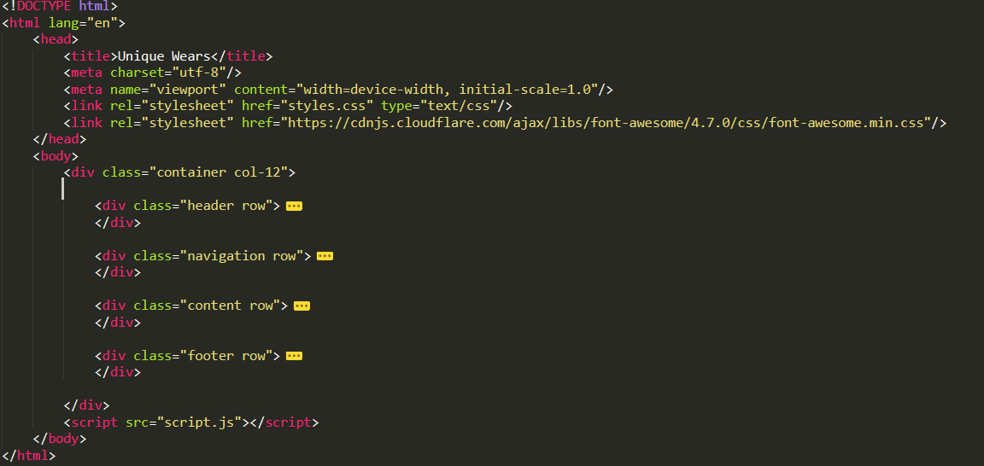

## CSS

**CSS** stands for **Cascade Stylesheet** it is a language developed by W3C. It describes how documents are displayed on screens and in print. It’s flexible, cross-platform and standards-based. It allows users to apply typographic styles like typeface or font size and instructions of page layout on a web page. (Terry Ann Felke-Morris 2012)

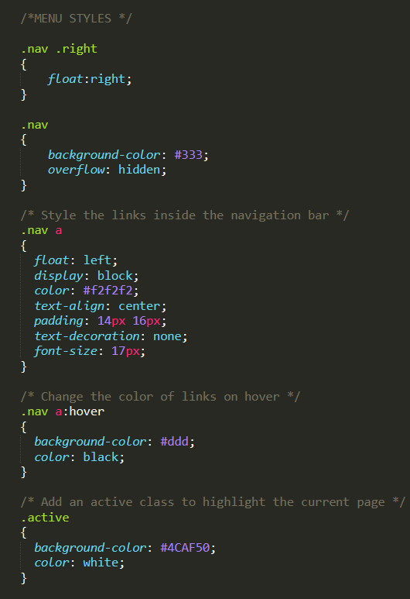

## Java Script

**JavaScript** is a client-sided scripting language, one of reasons why is because it is interpreted by a browser. It is object-based because it works with objects which are associated with a web document like the document itself, the browser window and elements such as forms, images, etc. So, we use Java Script to add functionalities like showing and hiding elements on the web page, initiating time, animating elements. Java Script is very useful and widely used across the world wide web. (Terry Ann Felke-Morris 2012)

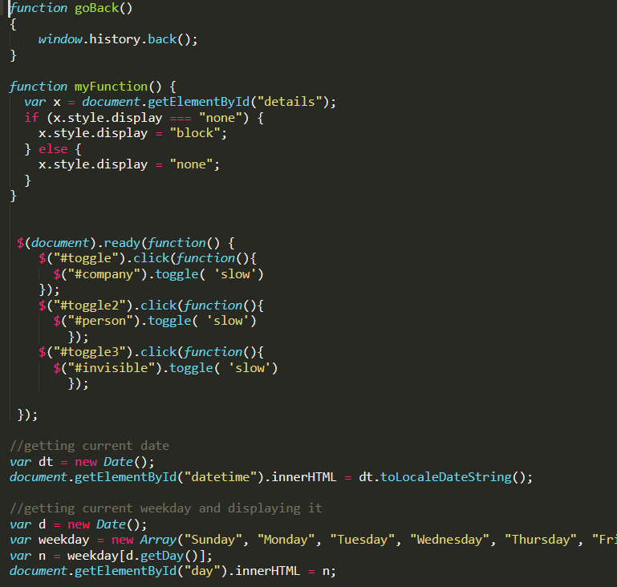

## Responsive Web Design

**RWD** stands for **Responsive Web Design** which is a designing concept that makes website work on different screen size devices. Because nowadays we can view website on PC, tablets and phones. It is making website responsive to screen size changes, so that your website will look good on every screen. What you basically do is divide your page into certain number of columns, calculate each space column will take and create appropriate classes in CSS and name your divisions classes in HTML corresponding with CSS to position your elements. (W3 Schools)

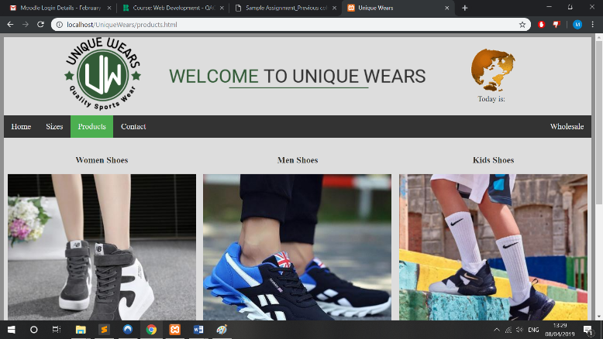 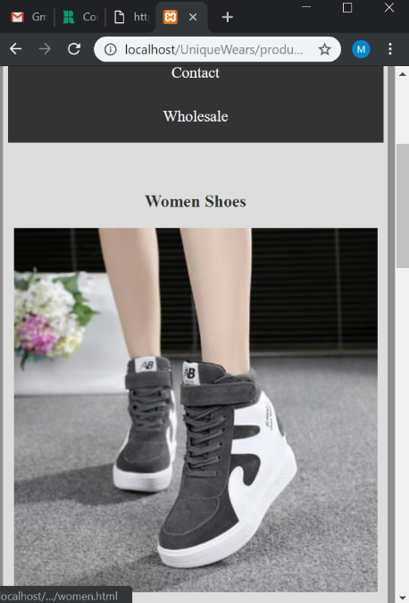

## Reflection

By doing the research I can see there are many tools that allow us to create a fully responsive and functional website. I could use more JavaScript to display elements on my website and to achieve some responsive features. I could also use bootstrap which is a CSS-Framework for creating responsive websites, widely used across the world wide web. (Bootstrap 2019) It would be much easier to create a bootstrap page but creating page on my own taught me a good lesson.

HTML and CSS at first may look simple but styling and coding the page to the desired effect takes more time than I thought it will. Despite that I finished my project, but I am not actually happy with it, with more time I could make it better.

# Usability and Accessibility

When designing a website, we need to think about people with disabilities like people suffering from blindness and low vision, deafness and hearing loss, cognitive disabilities, etc. Hopefully there are *Web Content Accessibility Guidelines* (WCAG) 2.0 it is a guideline covering a range of recommendations for making our content more accessible for everyone. There are 4 main principles that you must follow designing your website: Perceivable, Operable, Understandable, Robust. ((WCAG) 2.0 2008) Below I will describe how I tried to meet each point.

## Perceivable

“Information and user interface components must be presentable to users in ways they can perceive.”((WCAG) 2.0 2008)

Designing the website, I tried to make the website as user friendly as possible trying not to lose the website design and functionality. All the website images have alternative text it is for users with slower broadband. Therefore, the alternative text isn’t unique so when we have “women shoes image” that is all that user is getting instead of “an image of a woman trainer in red colour” that gives him better understanding of what is going to be displayed.

### Operable

“User interface components and navigation must be operable.” ((WCAG) 2.0 2008)

Going through with the requirements form w3.org I didn’t’ specify any functionality available from keyboard you can move using TAB button, but it is in normal order. There is no different page layout, but website layout has no fast flashing images and bright colours, so to my best knowledge I think page won’t cause any seizures, so it makes page operable.

### Understandable

“Information and the operation of user interface must be understandable.” ((WCAG) 2.0 2008)

Website is written in English language with no unique or strange words. There is no mechanism that allows less educated readers to understand the website but paragraphs are written in simple language.

## Robust

“Content must be robust enough that it can be interpreted reliably by a wide variety of user agents, including assistive technologies.” ((WCAG) 2.0 2008)

My website is validated using w3 validation. All elements are nested appropriately to their specifications and page can be displayed across any platforms like PC, tablets and phones. The page is fully responsive.

## Would you change anything and if so why?

I would use different approach for displaying product pages. The approach I did is straightforward and clear but from developer point of view it is very annoying. I have just 12 products per each product category this sums up to 60 product pages. So, when I decided that I will change the product page view I had to copy and paste the code to 60 different files making that quite annoying. I could do this by just displaying the division <div></div> with product information within the same page and hiding it while clicking on another product. Image below shows male product folder.

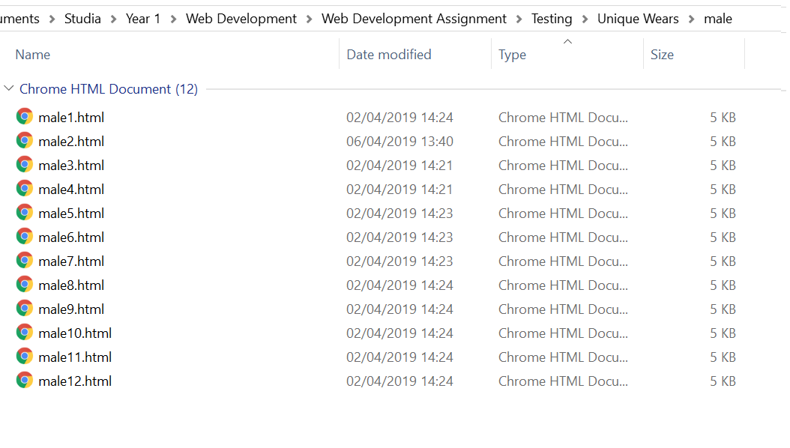

# Further Enhancements

## Create a user login page

I could also create a login page, so user could login in to their page using social media or their email. That could benefit because each client could have a unique shopping experience and it would be easier to maintain order queries.

## Use more java script for functionalities

As I mentioned before about changing the product pages I could accomplish it by applying more JavaScript to my website. I did it when I did the last page which was the wholesale page. You can choose if You are a Person or a Company and appropriate division show/hide. If I spend more time researching and learning about JavaScript I would be able to make a more user and developer friendly website.

Using JavaScript could also help with navigation bar. Instead of Products page being a separate page for showing categories I could make a drop-down menu from products linking to correct category pages like men, women, girls, boys’ shoes.

# References

1. (Jon Duckett 2011) Jon Duckett (2011*). HTML & CSS: design and build websites* Wiley-Blackwell
2. (Terry Ann Felke-Morris 2015) Terry Ann Felke-Morris (2015). *Web Development and Design Foundations with HTML5*, 7th Edition
3. (W3 Schools) *W3 Schools tutorials* available at: <https://www.w3schools.com/css/css_rwd_intro.asp> (accessed on 09/04/2019)
4. (Bootstrap 2019*) Bootstrap documentation* available at: <https://getbootstrap.com/docs/4.3/getting-started/introduction/> (Accessed on 11/04/2019)
5. ((WCAG) 2.0 2008) *Web Content Accessibility Guidelines* *WCAG 2.0* available at: <https://www.w3.org/TR/WCAG20/Overview>

(accessed on 11/04/2019)